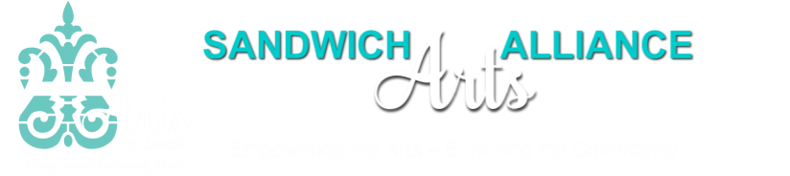

Second Annual
Plein Air Sandwich
Friday, August 3, 2018

An outdoor painting event for all levels!

PROSPECTUS
Plein Air Sandwich is a non-juried plein air painting event sponsored by the Sandwich Arts Alliance. The event starts with up to six hours of plein air painting at the artists’ location of choice within the Town of Sandwich. Artists must return their finished work to the Drunken Seal Restaurant, 98 Town Neck Rd, Sandwich, MA 02563, by 2:30 p.m. People's Choice Award will be announced at the Cocktail Hour Show & Silent Auction that evening. All paintings will be for sale and displayed on the display panels or on the artists’ own easels that evening.

Guidelines
- Plein air participants are responsible for providing their own easels, if needed, and all materials.
- The maximum size of the finished artwork is 30” x 30” including the frame if one is used (framing is optional).
- Artists must be fully registered and payment must be received online by July 27, 2018 in order to participate.
- The artist’s canvas and/or paper will be officially stamped on the back at check-in between 7:30 am - 9:00 am, August 3, 2018 at the the Stop and Shop, 65 Mass 6A, Sandwich, MA 02563. Please come to the parking area on the right side of the store.
- Artists may have more than one canvas or paper stamped; space may limit how many paintings will be in the show. At least one painting per participant will be shown.
- All paintings must be completed en plein air on August 3rd, 2018 in Sandwich without the use of photographs. No frames. Anything stretched must have wire or it’s own easel.
- All work in the show must be for sale in the Silent Auction. Artists shall indicate a bid starting price for the Show.
- People's Choice Award will be announced the evening of event.
- The show will remain on display during the event on August 3rd. All unsold work must be removed at the end of the event, but no sooner then 7PM.
- The Sandwich Arts Alliance will handle all sales retaining a 30% commission. Checks will be sent out within three weeks.
- This event will be held rain or shine.
- Plein Air Sandwich is open to all artists 18 years and older.
- No self-promotion or sales of other artworks will be permitted during this event. You are allowed to have business cards available while you are painting.

Thank you for your interest in Plein Air Sandwich. Space is limited to 30 artists so register early!

Dianna Benson
Chairwoman ~ Plein Air Sandwich 2018
jcaissie01@gmail.com

P.O. Box 1332, Sandwich MA 02563

www.sandwichartsalliance.org info@sandwichartsalliance.org
Sandwich Arts Alliance

Second Annual
Plein Air Sandwich

Plein Air - from the French phrase en plein air (in the open air) ,
the painting style developed by the French Impressionists circa 1870 to show the effects of atmosphere and light on the landscape.

Time Line

Friday, August 3, 2018

7:30 am to 9 am – Artist check-in and registration at the Stop and Shop on 6A.
Entrance fee must be paid in advance online. Paper and/or canvas will be stamped at this time.

9 am to 2:00 pm – Paint at location of your choice within the Town limits of Sandwich.

1:30-2:30 pm - All finished works, with titles and prices must be brought to the Drunken Seal Restaurant where it will registered and displayed for the judging. Anything stretched must have a wire. Late paintings will not be accepted.

5 pm to 7 pm - Cocktail Hour Show & Silent Auction

6:15 pm - People's Choice Award will be announced
We ask that all participants be in attendance for the awards announcement.

The show will remain on display during the event on August 3rd. All unsold work must be removed at the end of the event, but no sooner then 7PM.
Sandwich Arts Alliance
This space for Arts Alliance use.
Date Rcvd ______2018
Amount Paid $______

____ Member
____ Non Member

Second Annual
Plein Air Sandwich
Friday, August 3rd, 2018

REGISTRATION FORM

Name ______________________________________________________________________

Mailing Address______________________________________________________________

City ___________________________________ State _____ Zip Code _____________

E-Mail _____________________________________________________________

Phone ( ) _________________________________
Please provide cell phone in case we need to contact you during the event while you are out painting. Or please initial here: I do not have a mobile phone_______

Medium ________________________
Where do you expect to be painting? _____________________________________________
(Also, in case it rains, please consider a back-up location)

I have read and understand the prospectus.
I agree to abide by the guidelines.
I agree to leave my easel for display of my artwork, if needed.

Signature ______________________________ Date ____________________

Please check one: Accomplished or Amateur

On the day of the event—- between 7:30 am and 9 am. —-bring this completed form along with your canvas and/or paper to be stamped to the Stop and Shop parking lot Plein Air table. Once your surfaces have been stamped, you may begin.

